Database Assignment

Ques 1 Create Database

Commands

1. create database ttn;
2. use ttn;
3. show databases;

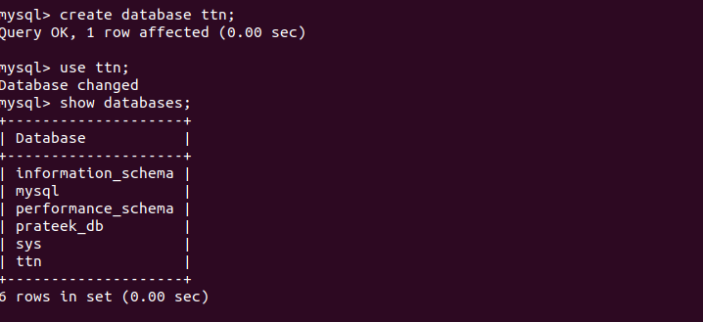

Ques 2 Design Schema

1. Customer

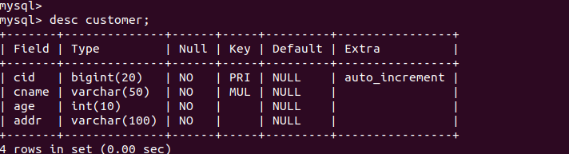

2. Product

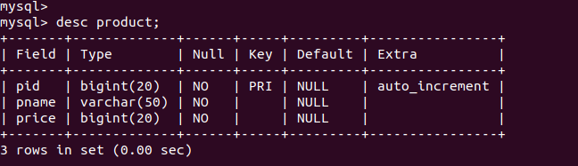
3. Salesperson

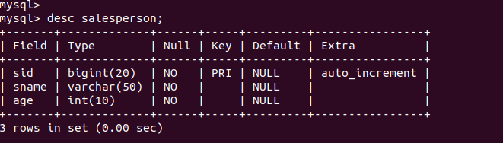

4. Orders

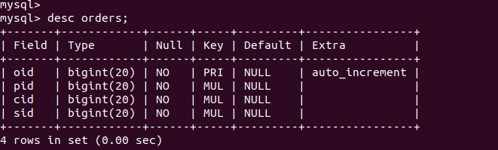

Ques 3 Create tables

Commands

1. create table customer(cid bigint(20) NOT NULL AUTO_INCREMENT, cname varchar(50) NOT NULL , age int(10) NOT NULL, addr varchar(100) NOT NULL,primary key(cid));

2. create table salesperson(sid bigint(20) NOT NULL AUTO_INCREMENT, sname varchar(50) NOT NULL , age int(10) NOT NULL,primary key(sid));

3. create table product(pid bigint(20) NOT NULL AUTO_INCREMENT, pname varchar(50) NOT NULL , price int(10) NOT NULL,primary key(pid));

4. create table orders(oid bigint(20) NOT NULL AUTO_INCREMENT,pid bigint(20),cid bigint(20),sid bigint(20),primary key(oid),foreign key(pid) references product(pid),foreign key(cid) references customer(cid),foreign key(sid) references salesperson(sid));



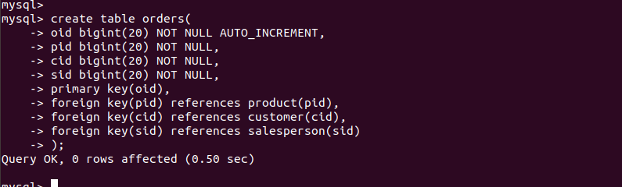

Ques 4 Insert sample data

Commands

1. insert into customer(cid,name,age,addr) values(1001,’prateek’,23,’noida’);
2. insert into product(pid,pname,price) values(101,’butter’,150);
3. insert into salesperson(sid,sname,age) values(10,’gaurav’,23);
4. insert into orders(oid,pid,cid,sid) values(1,101,1001,10);
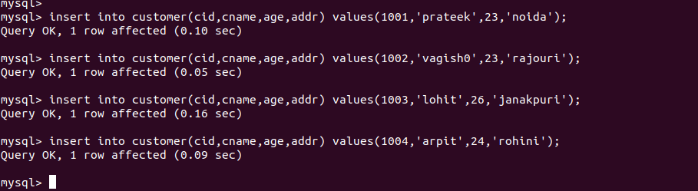
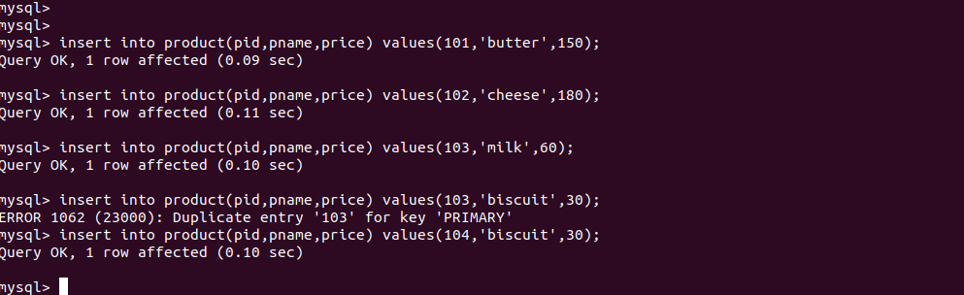
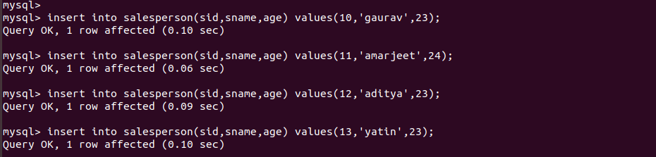
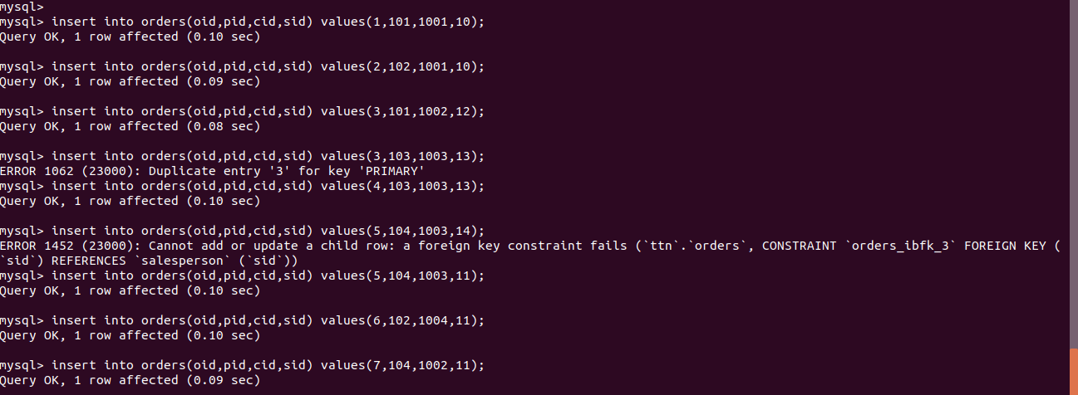

Ques 5 Find the sales person have multiple orders.

Commands

1. select sname,count(orders.sid) as totalorder from salesperon join orders on orders.sid=salesperson.sid group by orders.sid having totalorder>1;

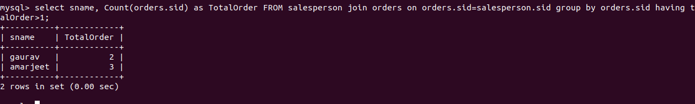
OR
1. select sname,count(orders.sid) as totalorder from salesperson right join orders on orders.sid=salesperson.sid group by orders.sid having totalorder>1;

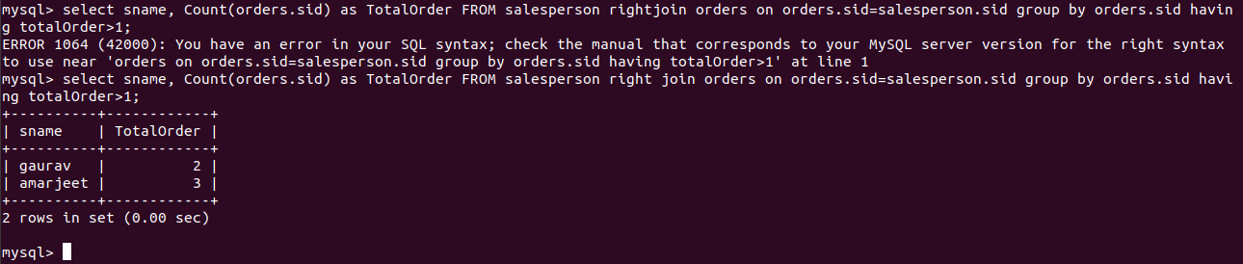

Ques 6 Find the all sales person details along with order details

Commands

1.select salesperson.*,orders.oid,orders.pid,orders.cid from salesperson join orders on salesperson.sid=orders.sid;

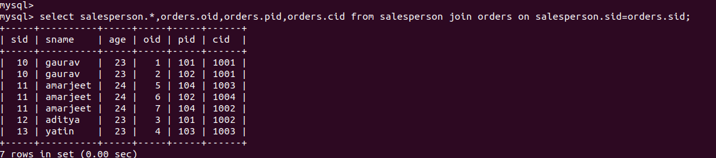

Ques 7 Create index

Commands

1. alter table customer add index cust_index(cname);

Ques 8 How to show index on a table

Commands

1. show index from customer;

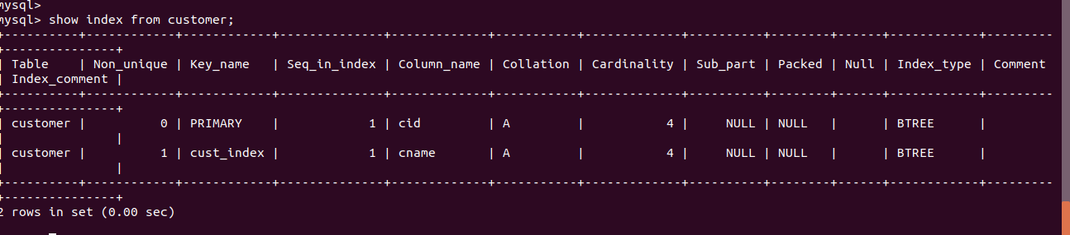

Ques 9 Find the order number, sale person name, along with the customer to whom that order belongs to

Commands

1. select oid,sname,cname from orders,salesperson,customer where orders.sid=salesperson.sid and orders.cid=customer.cid and orders.oid=1;

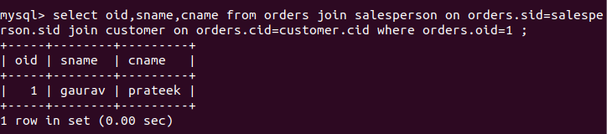

OR(below not specifying order id)

